WELCOME TO INTERNET2’S TOWARDS GIGABIT LIBRARIES TOOLKIT, FUNDED BY THE INSTITUTE FOR MUSEUM AND LIBRARY SERVICES (IMLS). THIS TOOLKIT IS DESIGNED FOR SMALL, RURAL, AND TRIBAL LIBRARIES WITH LIMITED INFORMATION TECHNOLOGY (IT) SUPPORT. THE GOAL IS TO IMPROVE AND EVOLVE LIBRARY STAFF UNDERSTANDING AND INTERACTION WITH THE LIBRARY’S BROADBAND CONNECTION AND SERVICES.
TABLE OF CONTENTS
1. Executive Summary
2. How to Use the Toolkit
3. Library Contact Information
4. TECHNOLOGY INVENTORY
A. Broadband Connection
B. Network Devices
C. Wired Network and Power
D. Wireless/WiFi Network
E. Computer/End User Devices
5. BROADBAND SERVICES AND ACTIVITIES
6. BROADBAND TECHNOLOGY AND OPERATIONS
7. BROADBAND FUNDING
8. Additional Resources and Best Practices
9. Glossary
10. Acknowledgements

1. EXECUTIVE SUMMARY
The purpose of this Toolkit and the entire process, including the Broadband Improvement Plan, is to support the library staff’s understanding of their library’s broadband connection and related IT infrastructure. The Toolkit uses questions, mini-training modules (via websites, YouTube videos, documents), and online tools to help library staff learn and potentially improve the library’s broadband connection. This Toolkit takes a focused “Broadband 101” look at the parts and pieces that make up the library’s connection to the Internet, from “the pipe” or wireless broadband coming into the library to WiFi/inside wiring configurations to broadband-based applications and computer resources—all at a level designed for lay people. By leveraging the Toolkit’s workbook/training format, library staff will better understand the facility’s broadband connection and its ability to support current and intended library broadband applications, and staff will be able to identify some short-term “quick hits” and longer term actions to improve the library’s broadband infrastructure. Further, library staff also will be able to better articulate to their leadership, policy makers, broadband service providers, and their community what the library needs in terms of broadband IT, in order to improve how their library digitally serves the community.

2. HOW TO USE THE TOOLKIT

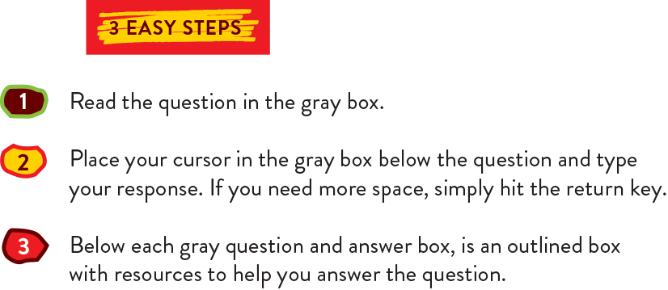
The Toolkit is designed to help library staff assess and evaluate their library’s broadband connection, including inside wiring. The Toolkit also serves as an educational training tool aimed at guiding library staff through the sometimes confusing world of broadband technology in an easy to understand and accessible way.
The Toolkit is organized as follows: Questions relating to the library's broadband connection, infrastructure, and related services and operations are posed in a series of gray boxes. The person using this toolkit may type the answers to these questions in the same gray boxes. “Help text” appears immediately below each question and is designed to assist in answering each question directly or provide additional guidance, education, detail, information and additional resources associated with the topic.
Some of the activities and training resources that library staff may do while engaging in the Toolkit are items that can be listed as a part of the library’s “Broadband Improvement Plan.”
In some instances, where available, working through the Toolkit with a technical resource (staff member, volunteer, etc.) is helpful.

3. LIBRARY INFORMATION

NAME OF LIBRARY:
Address:
Website:
Contact:
name, phone, email
Technical Contact:
name, phone, email

Toolkit Revision History:

Date | Completed/Updated By | Notes

4. TECHNOLOGY INVENTORY—YOUR LIBRARY
In this section, you will inventory some of the key pieces of the technology inside your library, including your network, computers, and other important technology components. This inventory will help you understand what sort of equipment you have now, and provides a basis to determine if you need different or additional equipment for the future.

4A. Broadband Connection
If you have more than one broadband connection, i.e., two different types of technologies or service providers, answer the following questions in this “Broadband Connection” question for each connection.

1. What type of internet connection does your library currently have?
Choose all that apply.
Digital Subscriber Line (DSL)
Cable Modem
Fiber
Wireless
Satellite
Other {add here}

There are three primary types of broadband—wireline (DSL, cable modem, and fiber), wireless, and satellite. Definitions for the types of Internet connections listed here are available at the FCC website: https://www.fcc.gov/general/types-broadband-connections
Speed Ranges by Type of Broadband (Kbps - kilobit, Mbps - megabit, Tbps - terabit)
Technology | Type | Download Speed Range | Upload Speed Range
Fiber | Wireline | 100 Mbps - 1 Tbps | 100 Mbps - 1 Tbps
Cable Modem* | Wireline | 256 Kbps - 10 Gbps | 256 Kbps - 10 Gbps
DSL* | Wireline | 256 Kbps - 100 Mbps | 256 Kbps - 16 Mbps
Fixed Wireless / Microwave | Wireless | 1 Mbps - 155 Mbps | 1 Mbps - 155 Mbps
Satellite | Wireless | 1 Mbps - 50 Mbps | 0.5 Mbps - 3 Mbps
*Upper end of speed range depends on type of DSL (VDSL2) or cable modem (DOCSIS 3.1) technology. In rural areas, DSL and cable modem more like to be a max of 45 Mbps download. Sources: FCC, How Stuff Works, CableLabs, NetworkWorld
Additional information on each type of broadband technology can be found in the U.S. Department of Agriculture’s Rural Development presentation “The Pros and Cons of Different Broadband Technologies” http://www.rd.usda.gov/files/AyleneMafnas-USDA.pdf

2. Who is your broadband service provider?
3. Who pays for your broadband service?

If you do not know your broadband service provider, this speed test tool will identify the provider for you: http://www.bandwidthplace.com/ To see the service provider, run the speedtest and below the results, hit “Show More” to get the name of the broadband provider. Please note: if your web browser is outdated, you may see an error message (if so, please check the website header for a possible link to the test).

4. Do you have more than one broadband service provider?
Yes
No
Unsure

Some libraries have two different broadband service providers, i.e., one that is terrestrial (fiber, DSL, cable) and one that is wireless (satellite, fixed wireless) to increase broadband speeds.
If unsure, you might have more than one broadband connection if you have two different routers (for more info, see the section on Network Devices) or two different WiFi networks available in your library. Connect to the two WiFi networks individually and run the above test to identify the service provider(s).
If you only have one broadband connection and the speeds are not sufficient or cannot be upgraded further, a potential solution is to get an additional broadband service/connection for the library, perhaps using E-rate funds if the library does not file for E-rate.
If you have more than one broadband service provider, please answer the questions below for both connections.

5. What are the options for broadband service providers/connection types in your area? Choose all that apply and write the name of the service providers (where available) next to the connection type.
Connection Type | Broadband Service Provider(s)
Digital Subscriber Line (DSL)
Cable Modem
Fiber
Wireless
Satellite
Other {add here}

Your state may have also created and still host and update a “Broadband Map” to help identify service providers in the state, mapped by location. Google the name of your state and “broadband map” to find it.
To see what research and education networks (non-profit broadband providers serving higher education) may be available in your state, try this listing from Internet2: https://internet2.edu/community/community-anchor-program/get-connected

6. What is the download and upload speed of your Internet connection (expressed in Mbps)? Measure your speed using the following (2) speed tests. Record your results in the table below.
- Test #1: Measurement Lab - https://www.measurementlab.net/tests/ndt
- Test #2: SpeedTest.net - http://www.speedtest.net

SPEED TEST RESULTS | Download | Upload
Test #1 Measurement Lab |  |  | Mbps
Test #2 SpeedTest.net |  |  | Mbps

It is best to test the speed when no one else might be using it, perhaps early in the morning before the library opens for the public and before other staff might be using the connection. It is also best to test the connection using a computer connected by an Ethernet cable (i.e. using a wired connection instead of wireless)connected computer, as close to the broadband router as possible.
For more information on checking your speed, the Texas State Library and Archives Commission has an instructional video: https://www.youtube.com/watch?v=B55BAc5Jtxc
Note that the bandwidth or speed of your connection is dependent on many variables, especially depending on the type of technology being used. Distance from the “last mile” broadband facilities is the most important. The further away, speeds decrease.
The Speed of your connection can also be impacted by your “middle mile” provider that works with your “last mile” broadband service provider. For more information on what can impact your broadband speed, please see a great article from the United Kingdom: http://www.thinkbroadband.com/guide/broadband-speed.html

7. Next, let's test the quality of your broadband service, specifically, the latency, jitter, and packet loss for your network connection.
Revisit your Measurement Lab speed test results page (https://www.measurementlab.net/tests/ndt/). Record your results in the table below.

Connection Quality Results
Latency |  | Milliseconds (ms)
Jitter |  | Milliseconds (ms)
Packet Loss |  | Percent (%)

Along with broadband speeds, the “quality” of your broadband connection is important, especially for video and audio applications.
The same Measurement Lab test (https://www.measurementlab.net/tests/ndt/) we used for speed will also provide the additional, “quality” measurements for your broadband connection.
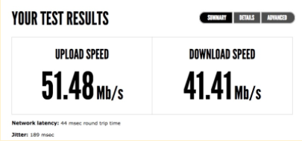

The latency and jitter measurements are located below the speed results on the main measurement results page, “Summary.” The packet loss measurement is on the “Details” tab and reported as “X.X % of packets lost during test.”
Three key network quality measurements are latency, jitter, and packet loss:
Latency: Measurement found below speed on “Summary” tab. It is the amount of time required for a data packet to get from point A to point B. It is usually measured in terms of round-trip delay expressed in milliseconds (ms). Higher quality connections have latency in the <100 ms range, the lower the better. Low latency is especially critical for real-time applications, such as live streaming video and interactive videoconferencing. For example, high latency causes a delay between when a person speaks and the party on the far end hears them, which can make two way conversations difficult. In other words, the video of the person speaking is delayed or out of sync with the audio.

Jitter: Measurement found below speed on “Summary” tab. Jitter is the amount of variation in the latency observed over time. Zero jitter means the amount of time it took for packets to go from point A to B were exactly the same every time. Anything above zero is the amount of time by which they varied. Similar to latency, you want your jitter measurement to be as low as possible, ideally <10ms.

Packet Loss: Measurement is found on the “Details” tab, and reported as “X.X% of packets lost during test.” Packet loss occurs when one or more individual data links along a network path needs to transmit more data than it has available bandwidth, i.e., congestion. Lost packets will either cause missing parts of a data stream, such as video that “tiles” or “pixelates,” or will cause other applications to slow down as the missing date from the lost packets are resent.

Network Quality Requirements for Applications in Milliseconds (ms)
Application | Minimum Bandwidth Required* | Max One-Way Latency | Max Jitter | Packet Loss
VoIP | 100 Kbps Up and Down | 150ms | 30ms | <1%
Desktop Video Chat | 0.5 Mbps Up and Down | 200ms | 30ms | <1%
High Definition Video Conferencing | 2 Mbps Up and Down | 100ms | 10ms | 0%
*Per single instance, i.e., one VoIP call or video chat
Source: Internet2, ITU, https://www.voip-info.org/wiki-QoS, Phone.Com, Ookla, Polycom, Lifesize
All networks have some level of latency and jitter. The lower the numbers for latency and jitter, the higher the quality of your data services. If your latency, jitter, and packet loss test poorly, share the results with your broadband provider and ask what can be done to improve performance.

Understanding the Relationship Between Broadband Speeds and Network Quality for Various Applications
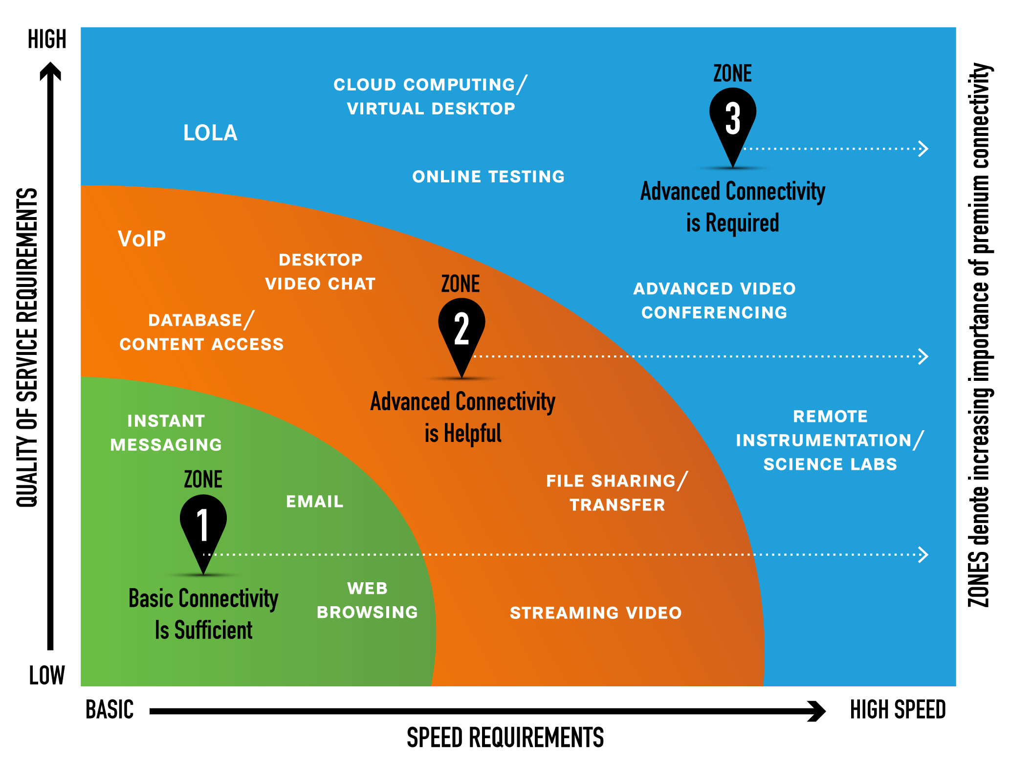

Sources: Connections, Capacity, Community: Exploring Potential Benefits of Research and Education Networks for Public Libraries, and Internet2.

8. Do you work with other libraries or schools to contract for your broadband service?
Yes
No

If yes, please describe how below:

Many schools and libraries are joining together to aggregate their buying power for better prices and services when signing broadband contracts with service providers or applying for E-Rate funds. For example, if the school or library is able to obtain a high capacity broadband connection, like fiber, and they are close by and in "line of sight," point to point wireless equipment on the roof of the institutions may allow the school and library share broadband connections.

9. How would you or your patrons describe the speed of your library’s wired Internet connection on a scale of 1 to 5 with 5 being best?
1
2
3
4
5

10. How would you or your patrons describe the consistency of the broadband speed, on a scale of 1 to 5, with 5 being always consistent/same speed and 1 being very inconsistent (slow sometimes or days, fine other days)?
1
2
3
4
5

11. How would you describe the reliability or quality of your library’s broadband connection?

Not reliable: There are daily outages.
Sometimes reliable: There are occasional outages (less than once a week).
Mostly reliable: Outages are rare.
Dependable: It would be a surprise to have an outage.
Very dependable: You cannot recall ever having an outage.

The purpose of these questions is a “gut check” to determine how fast or slow and how reliable the library’s internet connection seems to be based on your own perceptions as a user.
Below is a chart that provides estimated times it takes to download various file sizes based on the broadband speed.
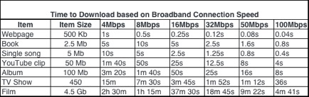
Sources: Wikipedia, FileCatalyst, Internet2
Some broadband technologies are negatively impacted by extraneous factors. For example, satellite broadband reliability can be impacted if there is bad or stormy weather. Cable
modem broadband can become congested during peak usage hours as it is based on a shared infrastructure—the more users on the network, fewer throughputs available and the network will be slower. Also, if there are a lot of users in the library, the network, locally, will be congested and users will see slower speeds.
It is important to track your network’s speeds and reliability to help troubleshoot any issues with your broadband service provider. When tracking issues with speed or reliability, note if there are a lot of users in the library, the time of day, and any bad weather. Also note if there is a difference between people accessing broadband via a wired connection, i.e., PC on a LAN, or via WiFi. All of this information will help to pinpoint any issues there may be in your broadband and IT infrastructure.

12. Does your broadband service provider provide the library with a static IP address (i.e., range of IP addresses)?
Yes
No
Unsure

Many libraries have access to online databases and other online resources. Libraries may purchase access these resources themselves or they may receive access to them as part of a consortium or statewide purchase. These resources are provided by companies such as EBSCO, Gale, and ProQuest. Access to these resources is limited to the library or group of libraries that are subscribing to the resources. The companies selling access to these resources provide libraries with multiple ways to authenticate their users. One way to authenticate users within
The library is to set up IP authentication. In order to set up IP authentication a library must have a static IP address or range of addresses.
To answer this question you will need to ask your ISP if your library is set up with a static IP address or range of addresses. If you have residential grade broadband connectivity, you likely do not have a static IP address. If you have business class broadband service you may have a static IP address or can call and ask for one.
If you have a computer running Windows 10 or 7, see this website for directions on how to check if you have a static or dynamic IP address:
http://www.techbout.com/check-ip-static-dynamic-4135/

4B. -- Network Devices
In this section, you will inventory the “heart and soul” of your network—the hardware components that make up your network. As you go through the questions about the various network devices, sketch out a diagram of the devices and how they are connected to one another. Instructions on how to draw a network diagram are at the end of this section. A sample network diagram on the next page will help walk you through this section:

EXAMPLE NETWORK DIAGRAM
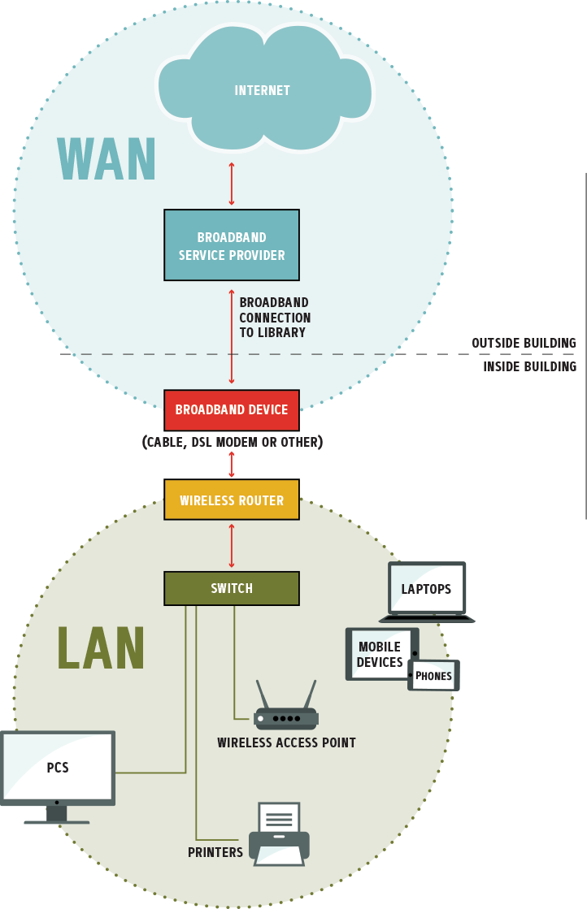
Yes
No
Unsure
1. Do you have a list of all of your broadband and IT equipment, including documentation on manufacturer, date purchases, log-in/password, etc.?

A best practice is to have a list of all broadband, network, and IT equipment, including PCs and other peripherals (like printers), documenting the following information:
- Manufacturer, model, and serial number
- Equipment purpose
- Location in library.
- Date purchased and installed
- Who owns equipment, i.e., broadband service provider, library
- Username and password (as applicable)
This document can help with IT support, as needed and provide documentation in case there is a loss at the library (theft, weather or structural damage at library). Keep a hard copy in the library and an online version (on email, cloud storage) in case the hard copy is lost.

2. What is the make/model of your broadband router?
Make:
Model #:

3. Do you have more than one router? If so, what is the make and model?

Make:
Model #:

A router is a networking device that forwards data packets between computer networks. A router is connected to two or more data lines from different networks. Your router is often a gray, black, or white device with multiple Ethernet ports for Ethernet cables.
You can find the make and model of your router by looking at it - the information may be printed on the top of the unit (as in this picture) or it may be located on the side or bottom, sometimes printed on a special label.
You will have a broadband router that connects your library’s network to the incoming broadband connection from the service provider, as well.

4. Does your broadband router also serve as a WiFi access point?
Yes
No

In many cases, the broadband router may also be a WiFi access point. Note that wireless routers can also serve as wireless points, but not vice versa.

5. How many WiFi routers and / or access points does your library have?
0
1
2
3
Other {add here}

WiFi routers and wireless access points (WAPs) are networking devices that allow WiFi-enabled devices to connect to a wired network. You need a wireless router, connected to your wired network in order to have WiFi in your library. WAPs help to extend the WiFi connection, are typically connected to a wired network and router.

6. What is the make and model of the WiFi router(s), if not the same as the broadband router?
Make:
Model #:

Understanding the make and model of the WiFi router is important when needing to change the WiFi settings. Each router manufacturer has their own WiFi settings modules and administrative logins that allow changes to the WiFi access point’s network name (SSID), channels, WiFi login and password, and process to install updated software (firmware) for the router. More information and a “how to” setup a WiFi router can be found here: http://www.wikihow.com/Set-Up-a-Wireless-Router
However, a best practice is to use the guide associated with your specific router. To find it, Google “(router manufacturer) (router model number) WiFi configuration.”

7. Do you have any network switches?
Yes
No
If yes, how many?

A network switch (also called switching hub, bridging hub, officially MAC bridge) is a computer networking device that connects devices together on a computer network, by using packet switching to receive, process and forward data to the destination device.

8. If you have more than one, how are your network switches connected to each other?
Our switches are daisy-chained with an Ethernet cable using an available network port on each switch.
Our switches use special high-speed ports to connect to each other
Other:
Please describe here:

The more devices that are daisy-chained (which is common) the slower the devices on the daisy-chain switches perform. Although some libraries daisy-chain switches together, it is not a best practice in terms of network speed and performance.
To reduce “daisy chaining,” have all data cabling possible run to central location to a single switch or combination of switches that are properly interconnected.
If you are daisy-chaining switches to increase your capacity (number of available switch ports), consider buying a single switch with higher capacity. Professional-grade switches typically come in 24-port or 48-port density.

9. How many empty switch ports do you have (i.e., how many ports do you currently have available to add more wired devices in the future)?
Number of empty ports:

Every one of your wired network devices, like PCs and printers, need its own switch port to physically connect to the network. Having extra capacity in your wired data network, in the form of empty switch ports “standing by” for future needs or requirements, is an excellent way to ensure your network has some room to grow. This is an exercise in simply counting. Take a look at the switches in your main data wiring area and count the number of ports that do not have cables plugged into them.
A best practice for a LAN is to hard wire all stationary devices (i.e., PCs, access points, printers) with Cat cabling and use WiFi connectivity for non-stationary devices (i.e., laptops, E-Readers).

10. Does your library network have any hubs?
Yes
No
If yes, number of hubs?

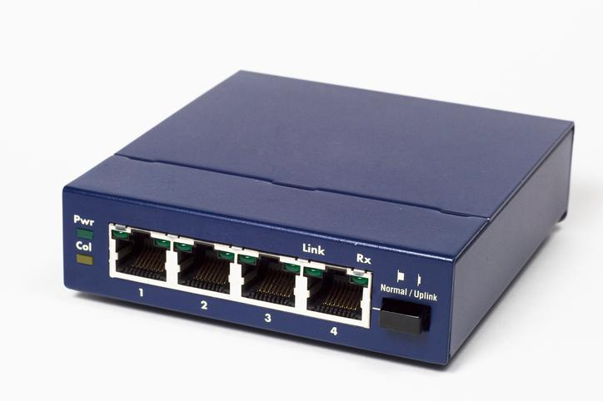
On a network, a hub (which is different from a switch, even though they often look identical) is a device connecting multiple segments of a local area network (LAN) and containing multiple ports. When a hub receives information (in the form of a packet) in one port, it copies that information to all of the other ports.
For a great explanation of the differences between a hub, a switch, and a router, see: http://www.webopedia.com/DidYouKnow/Hardware_Software/router_switch_hub.asp
Network “hubs” are obsolete networking technologies that perform poorly in modern data networks. If you have any “hubs” in your network you should consider replacing them with network switch or switches.

11. Do you have a "VoIP" (Voice Over Internet Protocol) or other IP Telephony system for your telephone service?
Yes
No

Modern digital voice telephone systems, otherwise known as VoIP systems, as opposed to older, analog telephone systems - use the library’s network to function, and may also impact the library’s Internet connection.
Some digital phone systems, such “Vonage”-type systems, a type of VoIP service, share the library’s Internet connection to provide voice telephony services for the library. Others use what are called SIP (Session Initiation Protocol) connections that do not impact the connection to the Internet.
In terms of the internal network, it is often recommended that digital phone systems are given their own, separate network. This is sometimes accomplished through advanced setups using VLANs (Virtual Local Area Networks) or simpler approaches (such as using a separate, dedicated network switch for the phone system).
If you are using a “Vonage”-type and experiencing issues with the quality of voice calls, you may need to ensure the performance of voice traffic by configuring “Quality of Service” (QoS) for telephone connection on your network. Many systems automatically give priority to voice calls, but some systems require manual setup.

12. If you are able, draw a simple diagram of your network.
Drawing a simple network diagram is easy. Here's a brief instructional video from the Texas State Library and Archives Commission (TSLAC): https://www.youtube.com/watch?v=nF_hoYlcNfY
You can draw your network by hand, or even try this online tool to create a network diagram using simple shapes and arrows:
Draw IO: https://www.draw.io/
Please see the Example Network Diagram on page 15.
As you draw your network map, you might find it helpful to add the make and model of your network components (including your router, switch, WiFi system and other components) to your network map.

4C. Wired Network and Power
The questions in this section are related to your library’s wired data network and the power capabilities of your building. A wired network uses Ethernet cables to transfer data between connected PCs, routers, switches, and wireless access points, depending on the configuration of the network. This part of your broadband IT infrastructure is also called “inside wiring” and creates the library’s “local area network” (LAN). Power capabilities refer to your library’s electrical system and how it is distributed to serve needs in your library.
1. Does your library have a wired data network?
Yes
No

If yes, what category of Ethernet cable do you have in your library? Check or highlight all that apply below:
Cat 3 (typically used for analog telephones)
Cat 5
Cat 5e
Cat 6
Cat 6a
I don’t know

2. Have you installed any new data cabling since your network was originally installed?

Yes, most or all cabling replaced
Yes, some cabling replaced
Yes, some cabling installed recently
No
I don’t know

Your library most likely has a wired data work, especially if it has a network switch or hub. Ethernet cables connect devices to one another and to the broadband router, often through a switch.
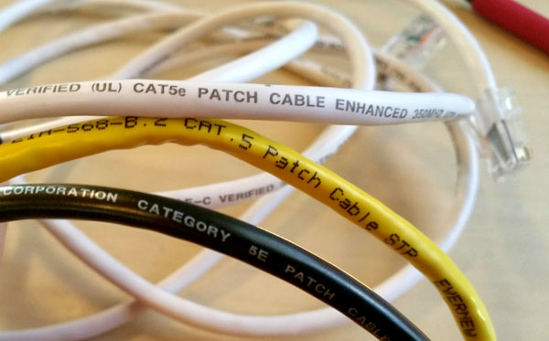
For your network to operate at its best, it’s important to know more about the speed capabilities of your Ethernet cabling. Some Ethernet cables can handle faster data speeds than others. The category (“Cat”) number of the cable tells you how fast your in-building cable can carry data. All quality data cables print the “Cat” ranking on the cable itself – like the examples in the photograph showing “CAT. 5” and “CAT5e” cables.
To find the “Cat” number of your cable, check the Ethernet cables attached to your router or switch. The Cat number should be printed somewhere on the Ethernet cable (Ethernet cables have larger than phone-jack style plugs/terminations).
Cat | Length* (meters) | 10 Mb/s | 100 Mb/s | 1 Gb/s | 10 Gb/s
Cat-5 | 100 m | Yes | Yes | No | No
Cat-5e | 100 m | Yes | Yes | Yes | No
Cat-6 | 100 m | Yes | Yes | Yes | No*
Cat-6a | 100 m | Yes | Yes | Yes | Yes

*At shorter distances, lower Cat cables can perform at higher speeds, for instance Cat-6 can transfer at 10 Gb/s over lengths up to 55 meters.
Category 3 cable is designed for analog telephone circuits and is not suitable for data connections. We recommend that you upgrade your data cabling as soon as possible to the current standard of Category 6 or 6a.

Category 5 and 5a cables are still good resources for library data cabling. If your budget permits, you might consider upgrading your cabling to category 6 or 6a.

If you are using category 6 or 6a - Excellent! You are in good shape in terms of your data cabling.

If your mix of data cabling includes any category 3 cabling it should be replaced soon with Category 6 or 6a. If you have some Category 5, you may consider upgrading to Category 6 or 6a in the future, but it’s not a crucial upgrade. If you already have Category 6 in your building, those cable runs are excellent.

If you don’t know what category of cable you have in your library, work with a person who can help you read the markings on the data cabling in your building.

3. How would you describe the quality of your inside wiring?
Poor quality
Average quality
High quality
I don’t know

This question may be difficult to answer - here are some factors to consider:
- Does your wiring look “messy”?
- Has your data cabling runs been tested or certified to ensure quality connections?
- Do you have any intermittent problems with certain connections?
- Does your wiring reach all parts of your building where it is needed?

4. Does any of your data cabling run parallel with electrical power cabling?
Yes
No

By its nature (literally using “twisted pairs” of wire), data cabling rejects electrical interference. However, it is still possible for the performance of data cabling (your inside wiring) to degrade if it comes into contact with electrical fields produced by sources such as power cables.
It is a best practice to never run data and power cabling parallel (side by side) or in the same conduits. When it’s necessary to cross data and power cabling, it is recommended that the cables cross each other at a 90-degree angle.
When there are no options other than to run data and power in parallel, data cabling with extra shielding should be used.
What about Power over Ethernet (PoE)? PoE Ethernet connections are where power for devices is carried on the same cable as the data. PoE systems use much lower power (measured in volts and micro-amperes) than standard “from the wall” electrical systems. Ethernet cabling is often referred to as “low voltage” cable and is constructed to allow for the power and data to exist on the same cable without causing interference.

5. Does your building have safe and adequate power capabilities to provide electricity?
Yes
No

This question is best answered by a licensed, qualified electrician, who can evaluate the total electricity demand your library has and compare it to the amount of power currently available to your building.
Any layperson, however, can often see the signs of unsafe and/or inadequate power. If you have experienced any of the following, it is recommended that you call in an electrician to perform an evaluation:
- Do your lights occasionally/randomly “dim” for brief periods of time? This is sometimes noticed when an appliance that uses a lot of electricity (such as microwave oven) is operated.
- Do you have circuit breakers that often “pop” (shutting of the electrical flow to a group of outlets or to special electrical circuits)?
- Are any of your electrical outlets not working?
- Do any of your light switches or electrical outlets feel warm or hot to the touch?
- Do any of your electrical connections (including light fixtures) make a buzzing or crackling sound - or even emit sparks? If yes, do any of these connections have a “burning” smell? Please note that it is normal for the electrical systems for fluorescent light fixtures to have a “hum” or buzz.

6. Does your library have adequate power receptacles where power is needed?
Yes
No

When many libraries were built, the need for power throughout the building (to serve the needs of network equipment, desktop computers and other devices for staff and patrons, to recharge portable devices and for many other needs) was not envisioned.
Take a look at places where power is needed and ask yourself if there are enough outlets to serve the needs and then address these needs with a local electrician and then address these needs with a local electrician.

7. Do you have surge protectors or uninterruptible power supplies (UPS) for sensitive or essential computing equipment?
Yes
No

Many library buildings struggle with fluctuations in the quality of the power to the building. Sometimes the power (measured in volts) is too low (also called a “brownout”); too high (also called a “power surge”) or even affected by huge spikes from lightning storms or other environmental factors.
For libraries in areas affected by frequent power surges, an investment in surge protectors is advised. Surge protectors come in various forms, but all are designed to protect sensitive equipment from overvoltage conditions that can damage or destroy the devices. Some surge protectors only work once (they protect the attached equipment by “blowing” an internal fuse) while others use a circuit breaker approach and can be reset after protecting equipment from a surge.
Uninterruptible Power Supplies (UPS) are often referred to as a “battery backup.” These units are designed to provide power to connected devices for a short time if the power fails. UPS units are often used for network equipment to ensure that network services keep functioning in the event of a power failure.
As an added bonus, some UPS units also provide “voltage regulation” capabilities to keep power quality within the acceptable range, and provide displays to show the voltages of power at the outlet and the regulated power supply.

4D. Wireless Network and Power

This section addresses the library’s wireless/WiFi network and provides insights in how to better manage routers, placement of wireless router/access points, and new technologies that can improve WiFi connectivity in your library.

“WiFi” is a term used to describe a technology that uses radio waves to provide wireless network connectivity, essentially wireless access to data networks. We usually use “WiFi” to refer to wireless connections to the Internet. Most Public Libraries in the U.S. provide WiFi for public Internet access.
1. Does your library provide WiFi to the following users?
Yes
No

2. Do you have separate Internet connections for staff and public access?
Yes
No

Some libraries have two broadband connections, one that is only for library staff and operations and the other for public computing devices and WiFi access for patrons.
Having separate Internet connections for staff and public use often allows for greater performance and higher security for your library.
If you are experiencing slowness or network congestion due to an overloaded network, you might consider adding an additional connection to serve the Internet needs for your staff and public networks separately. As well as the additional network connection, you may also need to purchase different or additional network components (including router and switch) as part of the solution.

3. Do you offer WiFi outside or surrounding your library building?
Yes
No
If yes, how many hours a day is WiFi available?

Many libraries allow their WiFi signal to “leak” outside of the library walls to serve patrons outside or after hours. Depending on your environment (especially proximity to private residences) you might consider increasing your WiFi coverage to include areas outside of your building.

The following document from Sno-Isle Libraries (serving Snohomish and Island counties in Washington state) on the rationale, best practices, and potential challenges of “going outdoors” with afterhours broadband access.
https://internet2.box.com/v/snoho
If WiFi is available outside of your library/in the surrounding area, you may want to make sure you have an Acceptable Use Policy (AUP) in place that includes use outside of the library. Some additional information about and examples you can leverage for an AUP: http://www.ala.org/advocacy/intfreedom/iftoolkits/litoolkit/internetusepolicies

4. Do any other organizations or businesses in your community offer free public WiFi?
Yes
No
If yes, list them here:

Some communities have many options for free access to the Internet, while others, especially rural communities, may have very few if any. If your library is the only place in the community offering free WiFi, besides local businesses like McDonalds or a coffee shop, you have some powerful reasons to seek more funding for your current Internet connection or to improve your connection.

5. If there are other places in your community to obtain free WiFi, how does your library WiFi compare in terms of quality?
Our library WiFi seems to be the only option in our community.
Our library WiFi seems slower or less-reliable than other options in the community.
Our library WiFi seems as fast and stable as other options in the community.
Our library WiFi seems faster and more stable than other options in the community.
Our library WiFi seems the fastest and most stable available in the community.
I don't know.

Some communities are fortunate to have a number of WiFi options, but sometimes the quality of those options are not as good or reliable as Public Library WiFi. If your offerings are better than other options, it’s an excellent opportunity to promote your services. In all cases, how you stand against other services is an opportunity to advocate for better broadband connections, newer equipment, and other needs you might have in serving your community.

6. How would you describe the reliability of your library's WiFi?
Not reliable: There are daily outages or periods of slowness.
Sometimes reliable: There are occasional outages or periods of slowness (<1/week).
Mostly reliable: Outages are rare and the connection is only occasionally slow.
Dependable: It would be a surprise to have a slowdown.
Very dependable: I cannot recall ever having an outage or slow period.

The most significant component of your library’s WiFi is the broadband connection that it is distributed through the WiFi router antenna(s). However, there are multiple things outside of the broadband connection that can be slowing down the WiFi connection, many of which can be addressed with quick fixes and laptop/smartphone tools (and are detailed at the end of this section):
- Congestion is often found in the WiFi frequency channels. Other, nearby WiFi routers / access points and other technologies (Bluetooth) may be using the same channel as your library’s WiFi network. To deal with this issue, change the channel or use a more advanced router. Generally 5 GHz model WiFi routers do not have these kind of congestion issues.
- Broadband router and/or WiFi access point needs to be “power cycled,” that is, turning each off for two to three minutes and turning back on.
- Location of the router is not optimal-- it is near a large wall limiting the wireless range, not centrally located, or next to large structures that may interfere with signal distribution. You can also buy a WiFi repeater/range-extender or new antenna to improve the range of the signals.
- Broadband router and/or WiFi access point should be running the current version of the “firmware.” Firmware is the software that runs on the router and access point, and just like a computer, needs updating every once in a while, too. You may find that you need to perform a firmware update for your router. Firmware updates are dependent on the type of router and directions on how to update can be found by visiting the website of the router.
If you’re having trouble with your WiFi, it can sometimes be tough to troubleshoot. There are a couple of simple tricks you can try -- even if you are a tech novice - to keep your WiFi humming.
“Cycle the power” on your WiFi Router on a regular basis: Sometimes the brain of your router can get a little “scrambled,” cycling the WiFi router-- in other words turning it off and on again(also called “rebooting”) -- can set things straight. Some libraries reboot their WiFi routers once a week at a time when there are no patrons using it such as first thing in the morning.
“Cycle the power” on your mobile device: The “brains” on mobile devices can get scrambled too. If just a particular device is having trouble connecting to the WiFi network, try rebooting it to see if it helps.
Move the router or extend its antennas: WiFi uses radio waves to send and receive data signals and sometimes those waves can be hindered or even blocked by building materials, walls, shelving and other elements. If your signal seems weak, try moving your router (moving it up high is an especially good one to try). When moving your router, be sure to take care that all cables remain properly plugged in -- or replace them with longer cables if needed. If your router has an external antenna or antennas, you can try extending those too, in different directions, to see if it helps.

7. What "flavors" of WiFi does your wireless router support? Check all that apply:
802.11a (54 Mbps, 5 Ghz)
802.11b (11 Mbps, 2.4 Ghz)
802.11g (54 Mbps, 2.4 Ghz)
802.11n (100 Mbps, 2.4 & 5 Ghz)
802.11 ac (1 Gbps, 2.4 & 5 GHz)
Other: {add here}
I don't know

WiFi, also known as its technical name of 802.11x supports different speeds, coverage range, and capacity as indicated by the lower-case letter that represented as an “x” in this sentence. You can answer this question by viewing the specifications published on the web for your WiFi router (just search your make and model number).
As the letter progresses up the alphabet, the better the performance speed, distance and capacity of the router.
The most modern WiFi routers support the “n” and “ac” speeds, those offer the highest performance for modern devices. Most routers, even the newest ones, will also support older speeds like “b” and “g” to ensure compatibility with older mobile devices.
If you replace your WiFi Router, we recommend a model that supports “n” and “ac.”
For more information about the different “flavors” of WiFi, see the toolkit glossary at the end of the document.

8. Which frequency bands does your WiFi system broadcast on?
2.4 GHz
5 GHz
Both

WiFi systems use two different frequency bands to provide wireless services: 2.4 gigahertz (GHz) and 5 gigahertz (GHz). Some systems broadcast on both bands simultaneously.
The 2.4 GHz band has been around the longest (and is also used by other wireless systems such as older cordless telephones, video cameras, and baby monitors). The 2.4 GHz band tends to provide a larger coverage area, but offers a slower connection speed than the 5 GHz band. It is also sometimes congested with other 2.4 Ghz networks or devices running nearby.
The 5 GHz band has faster speed capabilities, but offers a smaller coverage area than the 2.4 GHz band.
If you have a dual band router, a best practice is to broadcast both a 2.4 GHz and 5 GHz network as some older devices, i.e., E-book readers, tablets, PCs, may not be able to connect to the 5 GHz network.
To find out which frequency bands your WiFi system operates on, you will need to log into your router or you can search the web on your router manufacturer and model number.

9. Are there other WiFi networks running nearby (within a 100 foot radius) of your library building?
2.4 GHz
5 GHz
Both
If yes, there may be WiFi congestion that could be slowing down your WiFi services.

WiFi congestion is caused by multiple WiFi networks running on the same channel within the same WiFi frequency. This is often in 2.4Ghz WiFi systems. There are tools below that can help you identify overlapping WiFi networks (with neighbor WiFi networks). If you find overlap, you can change the channel your WiFi network uses on your router.
See below for tools to help you “see” the WiFi networks in your areas -- your own network, and others nearby.
10. Are there areas in your library where the WiFi connection is very low or undetectable (dead spots)?
Yes
No

Having consistent WiFi coverage throughout your building is considered a best practice; if you have dead spots you might consider adding an additional WiFi access point(s) to cover areas of your building where the signal is weak.
Often, you know where the WiFi in your building works and where it doesn’t through experience. There are tools (from this Toolkit) that can help you determine the signal strength of your WiFi router / access points in different parts of the building. Another tool highlighted below performs a “heat map” of your building to show WiFi coverage strength.

If you have areas of poor or no WiFi coverage, you might consider using WiFi “repeaters” or “extenders.” WiFi extenders communicate wirelessly with the primary WiFi system and receive the WiFi signal from the router and broadcast or “repeat” the signal into areas that need more WiFi coverage or signal. WiFi repeaters are hard wired connected to the WiFi router to extend or repeat the WiFi signal. In fact, many WiFi routers can double as repeaters. Some WiFi repeaters, “powerline adapters,” are plugged into the power outlet and Ethernet connected to the main WiFi router and second power outlet adapter is plugged into the area that needs broadband and a device can be Ethernet connected to it.

11. Do you have a "managed wireless or WiFi system?
Yes
No

A managed WiFi system is a software and hardware solution that provides an online interface to all components of the WiFi system in a location. It allows for a single interface to monitor and manage the WiFi network, even remote. These solutions interface with WiFi routers and access points and provide statistics on usage. A managed WiFi system is only worthwhile for sites with more than one WiFi router or access point and helps scale WiFi solutions for larger spaces. Some software/hardware companies that provide managed WiFi include UniFi, Meraki, Ruckus Wireless, and Open Mesh. Your broadband service provider or local IT company may also offer managed WiFi services.
12. Optional: Log into router to adjust administrative settings.

Advanced Wireless Configuration / Troubleshooting Via Your Router
If you’ve used one of the tools above to perform a scan, you are likely delighted to “see” what was previously invisible.
The information gathered can help you adjust settings in your router, if needed, to improve performance of WiFi.
To perform these advanced wireless activities, you will need access to login to your router. The login is usually performed via a web browser, and you will need to know your administrator username and password. The administrative settings of your router should always have a password that you or your technical staff has changed from the default password.
Basic guide to accessing your WiFi router (also known as “access point” or “configuration”) settings:
https://www.cnet.com/how-to/home-networking-explained-part-5-setting-up-a-home-router

13. Optional: Perform a scan of the WiFi environment in your library to see how your WiFi is performing. This is not applicable if you are running a managed WiFi solution.
If you perform a scan, share your thoughts about the results here.

Tools to try:
These software tools can operate on PCs and Macs as well as mobile devices with Android and Apple operating systems. These tools can automatically scan the WiFi networks in your library as well as others nearby.
Results from the software tools vary, but all can provide insight into your library WiFi, and you may wish to perform a scan with someone with knowledge of WiFi networks (and who can help you interpret the results).
Some of the software listed is free, and some is available for a fee. There are other options as well – to ensure you are using the best option for you at any given time, we recommend using technology review sources that you trust to help discover and evaluate the latest options.
PC: Acrylic WiFi Home (Available free for non-commercial use): https://www.acrylicwifi.com/en/wlan-software/wlan-scanner-acrylic-wifi-free/)
Mac: WiFi Explorer (available for a fee at the Mac App Store): https://itunes.apple.com/us/app/wifi-explorer/id494803304?mt=12)
IOS (iPhone; iPad:) Network Analyzer Lite (available for free from the iTunes App store): https://itunes.apple.com/us/app/network-analyzer-lite-wifi/id562315041?mt=8)
Android: WiFi Analyzer (available for free from the Google Play store): https://play.google.com/store/apps/details?id=com.farproc.wifi.analyzer&hl=en

4E. Computer and End User Devices

1. How many Internet connected computers do you have at your library?
Public computers
Staff only computers

Public Computers are those made available at the library for public use. Most often these are used to provide access to the Internet and access to “Office” applications such as word processing and spreadsheets. This may also include any computers that you have in a “training lab” or laptops that you allow patrons to use.

Staff computers are those that only staff are able to use and not available to the general public.

2. What are the average ages of your library computers, in percentages?
 | Download | Upload
1-3 years old |  |  | %
3-5 years old |  |  | %
> 5 years old |  |  | %

It’s a best practice to design your computer areas with the best possible experience for patrons in mind. When libraries have old or poorly maintained computers, it can give a negative impression. As well, computers that are more than 5 years old will not perform as well as newer computers. Older computers with slower processing power and less RAM can create the illusion that there is a slower broadband connection, especially with gaming, streaming, voice, and video conferencing applications. Further, when libraries have old or poorly maintained computers, it can put a significant burden on staff instead of making work easier.
- If your computers are 1-3 years old: Excellent! Your computers are relatively recent. Have you made plans or reserved budget dollars to replace your computers when they are 3 - 5 years old?
- If your computers are 3-5 years old: To ensure the best performance, replacing computers on a regular schedule is considered a best practice. If budgets allow, we recommend replacing computers within a 3-5 year timeframe.
- If your computers are more than 5 years old, you are likely experiencing performance problems. We recommend that you replace computers that are five years or older with newer models.

If you don’t know the age of your computers, work with someone in your community who can help you answer this question.

3. List the quantity and types of mobile devices that you provide to patrons for use inside your library. Mobile devices include tablets, laptops, eReaders, and other devices.
Laptops
Non-hard wired PCs
Tablets
eReaders
Other

Mobile devices are often “invisible” to you, but the more that you have in your libraries, the more demand is placed on your WiFi networks. The use of mobile devices are increasing and you want to be sure you have enough internal capacity (your WiFi network) and broadband capacity (your connection to the Internet) to serve this growing need.
Via your WiFi router configuration/settings, you can see the number of devices on the WiFi network. WiFi tuning tools, including those listed in the WiFi/Wireless section of this Toolkit can also help to identify what devices are connected.
See the “Advanced WiFi” section of this Toolkit to learn how your router can show you what devices are currently connected to your network.

5. BROADBAND SERVICES AND ACTIVITIES
In this section, the types of broadband services and applications are discussed in order to ensure that the library has sufficient bandwidth to support patron and staff use of various devices and applications both today and in the future.

1. How much bandwidth do you need? This can be tricky to estimate, with download speed recommendations ranging from 512 kbs to 1 mbs per simultaneous user, as described in this helpful and somewhat technical article: http://www.libraryedge.org/sites/default/files/Article-Benchmark9.2.pdf

Identifying how much bandwidth your library needs based on the types of services offered, number of devices connected, etc., can be difficult, especially as needs change over time and at different times of day.
Although not a technical measure, you may already know through experience if you have enough bandwidth or not. If you consistently experience a slow Internet connection when you have many people using your library computers and Wifi at the same time, it’s possible that your broadband connection is too slow for the demand.

Would you like to dig more deeply? This article offers an excellent description of an approach to produce a number: http://www.libraryedge.org/sites/default/files/Article-Benchmark9.2.pdf
This approach requires you to do some counting (the inventory you may have performed earlier in this toolkit will come in handy) and also do a little math.

The edge website also has resources on how to advocate within your community for better broadband.

2. Do you provide a broadband "hot-spot" lending program to your patrons?
Yes
No

Some libraries are loaning their patrons mobile wireless broadband “hot spots,” or devices that provide connectivity via cellular networks. This is enabling members of their community to patrons to “check out” the small wireless broadband device to create a WiFi hotspot at home to access the Internet. One resource: https://www.libraryjournal.com/?detailStory=hot-spot-techknowledge

3. Do you filter your Internet content? Check or highlight all that apply:
Yes, staff connection
Yes, all patron connections
Yes, some patron connections, ex. child, youth {list here}
No

Internet content filtering is something that some libraries employ in their public broadband connections in order to ensure that the connection is being used for lawful purposes. Further, libraries using E-Rate funds for their broadband connections are required to use content filtering to be compliant with the Children's Internet Protection Act (CIPA). Additional information on content filtering and related best practices can be found in the "Additional Resources and Best Practices" section at the end of this Toolkit.

4. If your library were less constrained by broadband limitations, what sort of services or applications would you like to offer your community?
Online testing
Distance Learning/Online courses
Videoconferencing
Virtual field trips for homeschool students
Job interviews
Patron video chat with family members and friends, etc.
Other: {describe here}
Streaming video (YouTube, etc.)
Makerspaces
eBook download

Add any additional ideas and aspirations on how your library would use more bandwidth in the box below:

Here are just a few examples of services and applications access to high quality, fast, and affordable broadband is enabling libraries around the country to offer their communities.
Presidential Primary Source Project (PPSP)
https://www.internet2.edu/research-solutions/community-projects/presidential-primary-sources-project/
Sponsored by the National Parks Service, U.S. Presidential Libraries and Museums, historic sites and museums, and the Internet2 community, PPSP offers schools and libraries a series of free interactive videoconferencing programs aimed at students in grades 5-12. PPSP is a great resource for homeschool students that use your library as their “classroom”.
LOLA
LOLA stands for “Low Latency.” It is a music performance application that allows musicians to perform together as if they were in the same room together. It requires gigabit connectivity to work properly though it is becoming increasingly possible to use the technology at lower bandwidth levels. Imagine your library hosting live musical events and enabling local musicians to come to the library for master classes with a music conservatory in New York city. While LOLA is a currently a “stretch goal” for most rural libraries we include it as an example to help get you thinking about what is possible when bandwidth is removed as a constraint from your library.
https://www.internet2.edu/research-solutions/community-projects/lola-for-all/
https://youtu.be/6QmLER1_bqg
https://www.youtube.com/watch?v=bgkIeygcRyo

6. BROADBAND TECHNICAL OPERATIONAL SUPPORT
Technology in libraries is more than just a collection of gear. People, including library staff and those who provide technical support, are just as important. In this section you will learn more about the people who help make technology available in your library and determine if there are any areas where you could benefit from additional support.
1. Describe the technology support available to your library.
Library staff expertise
Community volunteer(s)
Broadband provider or other IT service contract
State library
Local school district, municipal government or agency or other partnership.
Describe the technical support you receive from these sources below. What additional support does your library need?

Often small, rural, and tribal libraries have limited access or availability of technical resources to support the library’s IT and broadband infrastructure and operations.
Your state library may offer technical support for your library ranging from online resources, site visits, and in person and online training programs for library staff.
List of state libraries and archives:
- http://www.cosla.org/profiles
See “Section 9: Additional Resources and Best Practices” below for links to even more technology support opportunities for your library.

2. Do you have access to technology training resources for staff?
Yes
No
If yes, list:
If no, are there types of training you would like to receive?

3. Does your broadband service provider offer any type of technical support?
Yes
No
If yes, please list:

Technical Services from Your Broadband Provider
Your broadband service provider may be able to provide the library assistance with their broadband and networking needs. Services that a broadband provider could provide include managed router services. This type of support is often referred to as “managed network services.” Managed network services may include network device monitoring, firewall and security installation and management, related remote software updating, email and data center hosting, etc.
Managed services is beyond normal helpline/phone technical support, online technical support, and generally includes remote monitoring of the equipment and connection and in-person support.

4. How well does your broadband service provider respond to service requests?
Poor: Responds with direct support more than 24 hours after the request.
Fair: Responds with direct support within 12-24 hours after the request.
Good: Responds with direct support within 8-12 hours after the request.
Very Good: Responds with direct support within 4-8 hours after the request.
Excellent: Responds with direct support within 1-4 hours after the request.

5. Do you have any contracts or agreements with your broadband service provider indicating the speed of your broadband connection, service guarantees, or other factors?
Yes
No
I don’t know

Agreements describing the services you receive -- and the quality of those services -- are sometimes referred to as Service Level Agreements or “SLAs” for short. SLAs often define key items such as the speed of your connection, guarantees of uptimes, description and terms of service and support for your connection, remedies if services are not delivered as promised, and other elements.
An SLA “template” is here: http://www.slatemplate.com/. This link provides an example of many common elements within SLAs.
These agreements are an important starting point to understand what you’re purchasing from your broadband service provider, and are equally important to the broadband service provider to ensure they understand your needs and have the proper resources to ensure that your connection is the best that it can be.
If you have an SLA or other agreement, give it a read to see if it reflects your understanding of the services that you are purchasing. If you need help, consult the person who provides your technology support or a partner (such as a regional or state agency) to review and understand the terms of your services.

6. Do you have any contracts or agreements with your broadband service provider indicating the speed of your broadband connection, service guarantees, or other factors?
Yes
No

Beyond your broadband provider, IT companies can provide ad hoc or contracted, regular support visits to support the library’s broadband infrastructure.
Typical services often include hardware repair, software installation, network maintenance, and other items.
To find a reputable service provider, ask area businesses and other local public service organizations (K12 schools, local government) for suggestions on IT service providers.

7. BROADBAND FUNDING
Technology expenses are important budget considerations for all libraries. In this section you will learn about several opportunities available to help provide funding for your library broadband connectivity.
1. How much do you pay for your broadband connection?
i.e. what is full cost (what the service costs, including taxes, before any discounts, such as E-rate, are applied). Enter per month or year in the box below.

You will notice that your broadband bill has a lot of different “costs” associated with it, including:
- Service Cost
- Device Rental Cost (i.e., routers, access points)
- State and Local Taxes
- Universal Service Fund
(State and/or Federal government collects fees to subsidize telecommunications services for rural areas, schools, libraries, and health institutions, and low income households.)

2. Does your library currently take advantage of federal E-rate discounts for circuit/broadband connectivity or equipment costs?
Yes
No

For more information on the E-rate program, visit the Federal Communications Commission’s FAQs on E-Rate:
https://www.fcc.gov/consumers/guides/universal-service-program-schools-and-libraries-e-rate

3. If your library did not apply for E-rate funding, it was because (select all that apply):
The E-rate application process is too complicated.
The library staff did not feel that the library would qualify.
Our E-rate discount is low and we don't feel it is worth the time to participate.
The library receives E-rate discounts as part of a consortium, so it does not apply individually.
The library was denied funding in the past and is discouraged about trying further.
The library did not apply because of the need to comply with the filtering requirements of the Children's Internet Protection Act (CIPA).
The library applied for E-rate in the past but no longer finds it necessary.
The library receives its Internet access at no charge from the broadband service provider or other governmental entity.
Other: {add reasons here}

See “Section 9: Additional Resources and Best Practices” some E-rate resources and information. Note that some libraries partner with their local school for E-rate applications and connections to aggregate demand, reducing application burden and potentially increasing services.
The State Librarian Office may also have resources to help libraries apply for E-Rate. A list of State E-rate Coordinators can be found on the American Library Association’s website: http://www.ala.org/advocacy/e-rate-state-coordinators

4. Are you up to date with what the E-rate program allows libraries to receive discounts? i.e. internal network equipment and wiring and installation of fiber optic connectivity?
Yes
No

The Universal Service Administrative Company, an independent not-for-profit designated by the FCC, administers the Schools and Libraries (E-rate) Program. Check out the USAC website for the most up to date information on the E-rate program and how to get started
http://www.usac.org/sl/about/getting-started/default.aspx and check out the USAC FAQ page http://www.usac.org/sl/about/faqs/default.aspx

5. Does your library currently take advantage of local, state, private grants or other funding to assist with your technology funding?
Yes
No
If yes, please list:

Another source of funding could be through or associated with your State Librarian’s Office. Reach out to their office to see if there are grants, special funding, or training programs that may be available to your library.
http://www.cosla.org/profiles

8. ADDITIONAL RESOURCES & BEST PRACTICES
The topics listed here are designed to provide you even more insight and resources into improving your library’s broadband connectivity and services. You may find these items helpful in gaining a better understanding of your broadband connection, data network, and computers.
E-Rate
Library E-Rate
https://libraryerate.com/
Description: An E-Rate Clearinghouse for Libraries. Source: American Library Association (ALA), Chief Officers of State Library Agencies (COSLA), and Institute for Museum and Library Services (IMLS).
What is E-rate? https://www.webjunction.org/content/dam/WebJunction/Documents/webJunction/2015-10/handout-what-is-erate.docx
Description: A two-page overview on the basics of E-rate aimed at librarians just getting started. Source: Webjunction.
E-rate Timeline https://www.webjunction.org/content/dam/WebJunction/Documents/webJunction/2015-10/handout-erate-timeline.docx
Description: Learn about the key dates and deadlines for securing E-rate funding for your library. Source: Webjunction.
E-rate: What’s New for 2016? https://www.webjunction.org/events/webjunction/e-rate-whats-new-for-2016.html
Description: This Webjunction webinar and supporting materials covers the basics of the E-rate program and includes an orientation to the new E-Rate Productivity Center and the application process. Source: Webjunction.
Library E-rate Assessment and Planning (LEAP) project (http://www.cosla.org/content.cfm/id/leap)
Description: The Library E-rate Assessment and Planning (LEAP) project to ensure libraries are well-positioned to take full advantage of the opportunities made possible by the E-rate modernization changes. Source: COSLA.

Common Barriers and Solutions for Small Rural Libraries in Filing for E-Rate
( https://drive.google.com/file/d/0B67MuoyF-w3NbmI0TWROX0hNMm8/view?usp=sharing )
Description: Public libraries have many reasons for not participating in e-rate. We've tried to provide answers to the most common issues and concerns expressed by libraries that choose to not file for e-rate. Source: State Library of Iowa.

Content Filtering

Content Filters
(http://libraries.idaho.gov/icfl-funding-libraries/e-rate/content-filters)
Description: Provides an overview of filtering, FAQ, choosing a filter, implementing filtering policies, filtering options for DNS, software, and hardware filters. Source: Idaho Commission for Libraries.

Children's Internet Protection Act (CIPA) Key Issues for Decision Makers (http://www.webjunction.org/documents/webjunction/CIPA_Key_Issues_for_Decision_Makers.html)
Description: This article focuses on common questions being asked in the library community about CIPA. Source: Webjunction.
Filtering and the First Amendment (https://americanlibrariesmagazine.org/2013/04/02/filtering-and-the-first-amendment)
Description: Discusses what CIPA does and does not require and offers a best practices guide for providing CIPA-compliant filtering in a First Amendment friendly manner. Source: ALA’s American Libraries Magazine.
Alaska State Library Tech Talk “Web Filtering”
(http://lam.alaska.gov/filtering)
Description: This guide is a companion to the Tech Talk "Web Filtering" Source: Alaska State Library.

Additional Broadband 101 Resources

You Can Do I.T.! : Basic Network Technology for Libraries (https://onlinetraining.tsl.texas.gov/course/view.php?id=298)
Description: This free online course, designed for small, rural public libraries, explains network technology in approachable, straightforward language and allows for self-paced learning with the use of short YouTube videos. Source: Texas State Library Online Training.
Fiber to the Library (http://www.ala.org/aboutala/sites/ala.org.aboutala/files/content/oitp/PDFs/fiber%20brief_%20published.pdf)
Description: Articulates how public libraries can benefit from using fiber optics for their broadband internet connection. Source: American Library Association.
COSLA Planning Guide for Library Broadband Connectivity
Description: A guide for evaluating and acquiring high-capacity, high-quality broadband connectivity for local libraries. Source: COSLA.
A Technical Primer on Broadband Connectivity and Networking Strategies - Appendix A
Description: See pg. 51-57. In the first section, some of the basic elements of broadband connectivity are described. The second section reviews some of the low-cost options available to individual libraries that are encountering congestion difficulties and are seeking ways to ensure that their administrative operations can continue to function even as patrons’ Internet usage increases. The final section explains the benefits of cooperating with other libraries in addressing the need for greater bandwidth. Source: ALA Office for Information Technology Policy.
Connections, Capacity, Community: Exploring Potential Benefits of Research and Education Networks for Public Libraries (http://library.alaska.gov/pdf/anc/owl/CCCRENetworkPaper21Feb11.pdf)
Description: The purpose of this paper is to highlight ways in which, state research and education networks (R&E networks) and community anchor institutions, particularly public libraries, can collaborate to provide high-quality broadband connections for users in the communities they serve. Source: Bill & Melinda Gates Foundation.
School Wi-Fi Buyers guide (http://buyersguide.educationsuperhighway.org/learn/wireless/hardware)
Description: Aimed at K-12 schools but equally as valuable as a getting started guide for libraries. Source: EducationSuperhighway.

Wi-Fi Channel Optimizer
(http://www.pcworld.com/article/2943644/home-networking/5-free-wi-fi-tools-that-help-maximize-your-home-network.html#slide2)
Description: This article offers a list of 5 free Wi-Fi channel optimizer tools that can help improve the WiFi experience for your patrons and staff. Source: PC World.
Wi-FI Dead Spots/Coverage (http://www.ekahau.com/wifidesign/ekahau-heatmapper)
Description: HeatMapper™ is a free WiFi mapping tool that helps identify areas in your library where the Wi-Fi signal is poor or non-existent. Source: ekahau.

Free Technology Related Training Opportunities & Resources for Librarians

Free Training Webinars, Courses, and Other Resources (http://www.webjunction.org/find-training.html)
Description: Here you will find a variety of documents, webinars, and other resources aimed at helping rural libraries serve their communities in a scalable and sustainable manner. Source: Webjunction.
Infopeople Webinars and other Online Trainings (https://infopeople.org/training/view/webinar)
Description: Provides upcoming and archived training programs offered for free by Infopeople, a grant project of the Califa Group (link is external), is supported in part by the U.S. Institute of Museum and Library Services. Source: Infopeople.

Rural Library Sustainability Program
(http://www.webjunction.org/explore-topics/rlsp.html)
Description: Here you will find a variety of documents, webinars, and other resources aimed at helping rural libraries serve their communities in a scalable and sustainable manner. Source: Webjunction.

State Library Agencies Directory
(http://www.cosla.org/profiles)
Description: Use this list to find free technology training opportunities offered by your local state library agency. Source: COSLA.

Emerging Trends in Technology (https://infopeople.org/civicrm/event/info?id=536)
Description: As part of the Emerging Tech Trends series, this webinar introduces emerging technology trends and tipping points, and how these emerging trends are reshaping library services. Source: Infopeople.
A Technology Cookbook for Small and Rural Libraries (http://www.techsoupforlibraries.org/node/240)
Description: This all-encompassing cookbook contains chapters on configuring and maintaining public access computers, getting the technology training you need, setting up a wireless network, tech volunteer recruitment, and much more. Source: Tech Soup for Libraries.
Free Online Essential Technology Skills Training (http://www.gcflearnfree.org)
Description: Goodwill Community Foundation helps librarians and others gain the essential skills they need to live and work in the 21st century. From Microsoft Office and email to reading, math, and more, GCFLearnFree.org offers 125 tutorials, including more than 1,100 lessons, videos, and interactives, completely free. Source: Goodwill Community Foundation LearnFree.org.

Data Backup

The Rule of 3-2-1 (http://www.hanselman.com/blog/TheComputerBackupRuleOfThree.aspx)
Description: This blog post suggests the “rule of three” best practice around data backup-- always have three digital copies of anything you really care about, use at least 2 types of backup media (hard drive, tape, cloud), and at least one copy should be stored offsite. Source: Scott Hanselman blog post.
Your Organization's Backup Strategy (http://www.techsoup.org/support/articles-and-how-tos/your-organizations-backup-strategy)
Description: Is your organization prepared for a disaster? A solid backup strategy is one of the key elements of being prepared. Get started developing your organization's backup strategy with these tips and best practices. Source: Tech Soup.

Internet Use Policies

Internet Use Policy Toolkit (http://www.ala.org/advocacy/intfreedom/iftoolkits/litoolkit/internetusepolicies)
Description: The American Library Association (ALA) strongly encourages every library to adopt, implement and publicize a written Internet use policy in the same way it adopts other library use and access policies. This policy should be in keeping with your library's mission statement, other access policies and community needs. Source: The American Library Association.
Checklist for Creating an Internet Use Policy (http://www.ala.org/Template.cfm?Section=litoolkit&Template=/ContentManagement/ContentDisplay.cfm&ContentID=50647)
Description: Here are a few suggestions to consider when creating or updating your policies. Source: The American Library Association.
Library Computer Use and Internet Safety Policies (https://www1.maine.gov/msl/erate/internet-policies.pdf)
Description: The Maine State Library offers a comprehensive set of guidelines for developing Internet Use Policies. Included are links to several exemplar policies from libraries around the country and links to additional resources. Source: The Maine State Library.
Wireless Policy Checklist (http://www.techsoupforlibraries.org/blog/steal-this-wireless-policy-checklist)
Description: This article discusses how to ensure wireless use is covered in your Internet Use Policy. Source: Tech Soup for Libraries.

9. GLOSSARY

802.11a
A specification developed by the Institute of Electronic and Electrical Engineers (IEEE) for wireless LAN technology. 802.11 specifies an over-the-air interface between a wireless client and a base station or between two wireless clients.
802.11ac
A wireless LAN (WLAN) specification under development by the IEEE that delivers wireless data transfer rates in the range of 433 Mbps (Megabits per second) per spatial stream. With support for up to eight streams, the 802.11ac specification offers a theoretical maximum data transfer speed of more than 3 Gbps, and can deliver 1.3Gbps transfer speeds with a more common three-antenna (three streams) design.
802.11b
Also referred to as 802.11 High Rate or Wi-Fi, it is an extension to 802.11 specification developed by the IEEE for wireless LAN technology that applies to wireless LANS and provides 11 Mbps transmission (with a fallback to 5.5, 2 and 1 Mbps) in the 2.4 GHz band. 802.11b was a 1999 ratification to the original 802.11 standard, allowing wireless functionality comparable to Ethernet
802.11g
An extension to 802.11 specification developed by the IEEE for wireless LAN (WLAN) technology that is used for transmission over short distances at up to 54-Mbps in the 2.4 GHz bands.
802.11n
An extension to 802.11 specification developed by the IEEE for wireless LAN technology. 802.11n builds upon previous 802.11 standards by adding multiple-input multiple-output (MIMO). The additional transmitter and receiver antennas allow for increased data throughput through spatial multiplexing and increased range by exploiting the spatial diversity through coding schemes like Alamouti coding. The speed is 100 Mbit/s (even 250 Mbit/s in PHY level), and so up to 4-5 times faster than 802.11g. 802.11n also offers a better operating distance than current networks.
802.11x wireless
802.11 and 802.11x refers to a family of specifications developed by the IEEE for wireless LAN (WLAN) technology. 802.11 specifies an over-the-air interface between a wireless client and a base station or between two wireless clients. The IEEE accepted the specification in 1997.
Access Point (AP)
Is a device that allows wireless devices to connect to a wired network using Wi-Fi, or related standards. The AP usually connects to a router (via a wired network) as a standalone device, but it can also be an integral component of the router itself. Also referred to as an Wireless Access Point (WAP)
Backup
In computing, a backup is any copy of a file stored on a medium separate from the location of the original data. “Backup” can also be used as a verb meaning to perform the copying of original files to a separate medium. The purpose of backups is to have copies of important information in case of failure or damage to the originals. Best backup practices follow the “rule of 3-2-1,” which states that you should have three digital copies of any important data. These should be stored on two separate mediums (such as on an external hard drive, network drive, thumb/USB drive, or in cloud storage), and at least one copy should be stored off-site in case of disaster, etc.
Broadband
Broadband is the word used to, generally speaking, describe high-speed telecommunications and, more specifically, high-speed internet. Operating at, responsive to, or comprising a wide band of frequencies (a broadband radio antenna); of, relating to, or being a high-speed communications network and especially one in which a frequency range is divided into multiple independent channels for simultaneous transmission of signals (as voice, data, or video). The FCC currently defines broadband as 25 Mbps download and 3 Mbps upload.
Broadband Service Provider
An organization that provides services for accessing, using, or participating in the Internet. Internet service providers may be organized in various forms, such as commercial, community-owned, non-profit, or otherwise privately owned.
Also known as an “Internet Service Provider (ISP).”
Category (Cat) 5 Cable
Cat 5 is a twisted pair cable for carrying signals. This type of cable is used in structured cabling for computer networks such as Ethernet. The cable standard provides performance of up to 100 MHz and is suitable for 10BASE-T, 100BASE-TX (Fast Ethernet), and 1000BASE-T (Gigabit Ethernet). Cat 5 is also used to carry other signals such as telephony and video.
Category (Cat) 5e Cable
The category 5e specification improves upon the category 5 specification by tightening some crosstalk specifications and introducing new crosstalk specifications that were not present in the original category 5 specification. The bandwidth of category 5 and 5e is the same – 100 MHz. The differences between category 5 and category 5e are in their transmission performance. Category 5e components are most suitable for a high-speed Gigabit Ethernet. While category 5 components may function to some degree in a Gigabit Ethernet, they perform below standard during high-data transfer scenarios.
Category (Cat) 6 Cable
A standardized cable for Gigabit Ethernet and other network physical layers that is backward compatible with the Category 5/5e and Category 3 cable standards. Compared with Cat 5 and Cat 5e, Cat 6 features more stringent specifications for crosstalk and system noise. The cable standard provides performance of up to 250 MHz and is suitable for 10BASE-T, 100BASE-TX (Fast Ethernet), 1000BASE-T/1000BASE-TX (Gigabit Ethernet) and 10GBASE-T (10-Gigabit Ethernet).
Device Authentication--MAC Address
Is used to authenticate devices based on their physical media access control (MAC) address. While not the most secure and scalable method, MAC-based authentication implicitly provides an additional layer of security authentication devices. MAC-based authentication is often used to authenticate and allow network access through certain devices while denying access to the rest. For example, if clients are allowed access to the network via station A, then one method of authenticating station A is MAC-based. Clients may be required to authenticate themselves using other methods depending on the network privileges required.
Endpoint
Anything attaches to the network, including PC, laptop, tablet, phone, iPod, etc.
Ethernet
A computer network architecture consisting of various specified local-area network protocols, devices, and connection methods.
Ethernet Port
An Ethernet port is an opening on computer network equipment that Ethernet cables plug into. Ethernet ports accept cables with RJ-45 connectors, including Cat cables.
Firewall
A Firewall is a network or computer component (either hardware or software) intended to block unauthorized users from accessing a private network or computer while still allowing outward exchange of data.
Gateway
A wireless gateway routes packets from a wireless LAN to another network, wired or wireless WAN. It may be implemented as software or hardware or combination of both. Wireless gateways combine the functions of a wireless access point, a router, and often provide firewall functions as well.
Hub
On a network, a hub is a device connecting multiple segments of a LAN and containing multiple ports. When a hub receives information (in the form of a packet) in one port, it copies that information to all of the other ports.
For an explanation of the differences between a Hub, a Switch and a Router, see: http://www.webopedia.com/DidYouKnow/Hardware_Software/router_switch_hub.asp
Internet Service Provider (ISP)
An organization that provides services for accessing, using, or participating in the Internet. Internet service providers may be organized in various forms, such as commercial, community-owned, non-profit, or otherwise privately owned.
Also known as “broadband service provider.”
IP Address
An IP address is a unique string of numbers separated by periods that identifies each computer using the Internet Protocol to communicate over a network.
IPv6
Internet Protocol version 6 (IPv6) is the latest version of the Internet Protocol (IP), the communications protocol that provides an identification and location system for computers on networks and routes traffic across the Internet. IPv6 was developed by the Internet Engineering Task Force (IETF) to deal with the long-anticipated problem of IPv4 address exhaustion. IPv6 is intended to replace IPv4.
Jitter
Jitter refers to a variation in the typical amount of delay between sender and receiver. In data networks, it’s the measure of the variation over time of the latency of the network. Jitter is undesirable because it means the information relayed is delayed or otherwise interrupted.
Last Mile
The last mile is a colloquial phrase widely used in the telecommunications, cable television, and Internet industries to refer to the final leg of the telecommunications networks that deliver telecommunication services to end-users (customers).
Latency
Latency is the amount of time required for a data packet to get from point A to point B. It is usually measured in terms of round-trip delay expressed in milliseconds. Higher quality connections have latency in the <100 ms range, the lower the better. Low latency is especially critical for real-time applications, such as live streaming video and interactive videoconferencing.
Local Area Network (LAN)
A local area network (LAN) is a computer network that interconnects computers within a limited area such as a home, school, computer laboratory, or office building, using network media.
Managed Network Services
Services offered, often remotely, via a contracted service provider that manages and assumes responsibility for providing a defined set of services to the client, often automatically or on an as-needed basis.
Packet
A packet is the unit of data that is routed between an origin and a destination on a network or over the internet.
Packet Loss
The failure of one or more transmitted packets to arrive at their destination, causing noticeable interruptions in a transmission.
Router
A router is a networking device that forwards data packets between computer networks. A router is connected to two or more data lines from different networks.
SSID (Service Set Identifier)
SSID is a case sensitive, 32 alphanumeric character unique identifier attached to the header of packets sent over a wireless local-area network (WLAN) that acts as a password when a mobile device tries to connect to the basic service set (BSS) -- a component of the IEEE 802.11 wireless LAN architecture.
Switch
A network switch (also called switching hub, bridging hub, officially MAC bridge) is a computer networking device that connects devices together on a computer network, by using packet switching to receive, process and forward data to the destination device.
Transmission Control Protocol/Internet Protocol (TCP/IP)
The suite of communications protocols used to connect hosts on the Internet. TCP/IP uses several protocols, the two main ones being TCP and IP. TCP/IP is built into the UNIX operating system and is used by the Internet, making it the de facto standard for transmitting data over networks.
Wide Area Network (WAN)
Most networks consist of two major zones—the local area network (LAN) and the wide area network (WAN). A LAN is the internal network, whether it is a house with two computers or a high-rise office building with thousands doesn’t matter. The WAN is the network outside the LAN; this is both other internal networks and the full Internet. A WAN port is the portal by which information passes back and forth between the LAN and the WAN.
WAN Port
(WAN Stands for Wide Area Network). Most users will find a WAN port on a network router. A common home router has one WAN port and four LAN ports. Some routers refer to them as an uplink (for the WAN port) and wired connections (for LAN ports). The WAN port takes in information from the outside network or the Internet. The information is filtered through the router’s internal firewall and routing system. Then the information is sent to the proper LAN port or out over a wireless connection to a wireless source.
Wired Network
A wired network uses Ethernet cables to transfer data between connected PCs, routers, switches, and wireless access points, depending on the configuration of the network.
Wireless Access Point (WAP)
A device that allows wireless devices to connect to a wired network using Wi-Fi, or related standards. The WAP usually connects to a router (via a wired network) as a standalone device, but it can also be an integral component of the router itself. Also referred to as an Access Point (AP).

10. Acknowledgements

The project was led by PI Susannah Spellman, Internet2; co-PI James Werle, Internet2; and consultant Carson Block.

A team of 20 subject matter experts from higher education, state libraries, state and regional R&E networks were convened early to help guide and inform the work of the project, and later to help evaluate the process and results.

The project team appreciates the time and efforts of those assisting in the development of the toolkit. Over thirty state library and R&E network staff were engaged to assist in conducting the pilots in eleven states including Alaska, Arizona, Connecticut, Idaho, Kansas, New Mexico, Oklahoma, Pennsylvania, South Dakota, Texas, and Washington.

The project team would like to thank the rural and tribal library staff members who contributed their time and energy for the pilot visits.

This work is licensed under a Creative Commons Attribution-NonCommercial-ShareAlike 4.0 International License.

